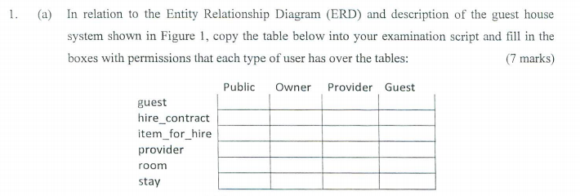

<https://chartio.com/resources/tutorials/how-to-create-a-user-and-grant-permissions-in-oracle/>

|  |  |  |  |  |
| --- | --- | --- | --- | --- |
|  | **Public** | **Owner** | **Provider** | **Guest** |
| **Guest** |  |  |  | insert |
| **Hire_Contract** |  |  | Select, insert, update & delete | insert |
| **Item_for_Hire** | select | Select, insert, update & delete | Select, insert, update & delete | select |
| **Provider** | select | Select, insert, update & delete |  |  |
| **Room** | select | Select, insert, update & delete |  |  |
| **Stay** | Select & insert | Select & update |  |  |

**GRANT**

**SELECT,**

**INSERT,**

**UPDATE,**

**DELETE**

**ON**

**schema.books**

**TO**

**books_admin;**



Select count(*)

From guest

join stay on ( stay.guest_no = guest.guest_no)

where stay.startdate between TRUNC(TO_DATE(’05-01-2018’, ‘DD-MM-YYYY’)) AND TRUNC(TO_DATE(’05-01-2018’, ‘DD-MM-YYYY’)) +0.999999 ;

<https://www.youtube.com/watch?v=jWKa1UcvCsQ>



CREATE OR REPLACE VIEW CONTRACTPROVIDER AS

SELECT GUEST_NO

FROM HIRE_CONTRACT

JOIN ITEM_FOR_HIRE ON (ITEM_FOR_HIRE.ITEM_KEY = HIRE_CONTRACT.ITEM_KEY)

JOIN PROVIDER ON (PROVIDER_PROVIDERID = ITEM_FOR_HIRE.PROVIDERID)

WHERE PROVIDER_NAME = ‘Paddy Joe Flanagan’ AND date_from > TRUNC(TO_DATE(’01-01-2018’,’DD-MM-YYYY’));

SELECT LAST_NAME, FIRST_NAME

FROM GUEST

WHERE GUEST_NO IN (SELECT GUEST_NO FROM CONTRACTPROVIDER);



Select providerid, provider_name from providers

Leftouter join item_for_hire on

item_for_hire.providerid = provider.providerid

where item_key = null;

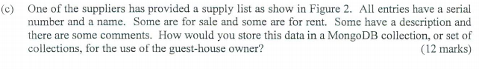

{

Supplier_name: ‘Jacks fishing supplies’,

address: ’23 Main Street’,

telephone_name: ‘090111111’

items: [

{

_id: ‘1’,

serial_no: ‘WEL2000’,

name: ‘Wellington Boots’,

sale_status: ‘For Sale’,

sale_cost: ‘€10-€50’,

hire_status: ‘For Hire’

hire_cost: ‘€5/day’,

availablity: ‘Check availability’,

item_description: ‘An assortment of sizes and colours’

},

{

_id: ‘2’,

serial_no: ‘GAR1000’,

item_name: ‘WindBreaker,

sale_status: ‘For Sale’,

sale_cost: ‘€50-€150’,

item_description: ‘An assortment of thickness, colours and sizes’

},

{

_id: ‘3’,

serial_no: ‘BAG1000’,

item_name: ‘Waterproof bag,

sale_status: ‘For Sale’,

sale_cost: ‘€60’

},

{

_id: ‘4’,

serial_no: ‘COO00’,

item_name: ‘Portable cooler,

hire_status: ‘For Hire’

hire_cost: ‘€50/day’,

available: ‘Check availability’,

},

{

_id: ‘5’,

serial_no: ‘BOA1000’,

item_name: ‘Fish Finder,

hire_status: ‘For Hire’

hire_cost: ‘€40/day’,

available: ‘Check availability’,

item_description: ‘Shows where fish are’

},

{

_id: ‘6’,

serial_no: ‘BOA2000’,

item_name: ‘Life Jacket’,

sale_status: ‘For Sale’,

sale_cost: ‘€90’,

hire_status: ‘For Hire’

hire_cost: ‘€30/day’,

available: ‘Check availability’,

item_description: ‘Comes in assorted sizes’

},

{

_id: ‘7’,

serial_no: ‘FIS1000’,

item_name: ‘Assorted tackle’,

sale_status: ‘For Sale’,

sale_cost: ‘€200’,

},

{

_id: ‘8’,

serial_no: ‘FIS2000’,

item_name: ‘7 foot Boat Rod and Reel’,

sale_status: ‘For Sale’,

sale_cost: ‘€200’,

hire_status: ‘For Hire’

hire_cost: ‘€30/day’,

available: ‘Check availability’,

item_description: ‘Accessories not included’

},

{

_id: ‘9’,

serial_no: ‘FIS2000’,

item_name: ‘8 foot Boad Rod and Read’,

sale_status: ‘For Sale’,

sale_cost: ‘€250’,

hire_status: ‘For Hire’

hire_cost: ‘€35/day’,

available: ‘Check availability’,

item_description: ‘Accessories not included’

}

]

}



SELECT COUNT(GUEST_NO) FROM STAY

WHERE STAY_CONFIRMED **IS NOT** NULL AND TO_DATE(’2018-01-05’,’YYYY-MM-DD’) **BETWEEN** STARTDATE **AND** ENDDATE;

Which guests (last_name and first_name) have made a contract (hire_contract) to hire items provided by a provider named Paddy Joe Flanagan after 1s Jan 2018

SELECT FIRST_NAME, LAST_NAME

FROM GUEST

JOIN HIRE_CONTRACT ON HIRE_CONTRACT.GUEST_NO = GUEST.GUEST_NO

WHERE DATE_FROM > TO_DATE(‘2018-01-01’,’YYYY-MM-DD’) AND

ITEM_KEY **IN** (SELECT ITEM_KEY FROM ITEM_FOR_HIRE

JOIN PROVIDER ON PROVIDER.PROVIDERID = ITEM_FOR_HIRE.PROVIDERID

WHERE PROVIDER_NAME = ‘Paddy Joe Flanagan’;



SELECT PROVIDERID, PROVIDER_NAME

FROM PROVIDER

WHERE PROVIDERID

**NOT IN** ( SELECT PROVIDERID FROM ITEM_FOR_HIRE);

select count(guest_no)

from stay

where

startdate <= "2018-01-05" and

enddate >"2018-01-05" and

stay_confirm is not null;



select last_name, first_name

from hire_contract

join item_for_hire using(item_key)

join guest using(guest_no)

join provider using(provider_id) // received when joining item_for_hire

where date_to > "2018-01-01" and

lower(provider_name) like 'paddy joe flanagan';



// this solution has many variations, use the one that feels the most intuitive..

1. using subqueries

select providerid, provider_name

from provider

where providerid not in (

select providerid from item_from_hire

);

**other alternatives**

2. using set operation

select providerid, provider_name

from provider

**minus**

select providerid, provider_name

from item_for_hire

join provider using(provider_id); // needed because they have to have the same columns

2. using joins

select providerid, provider_name

from item_for_sale

left join provider using(providerid)

where providerid is null;

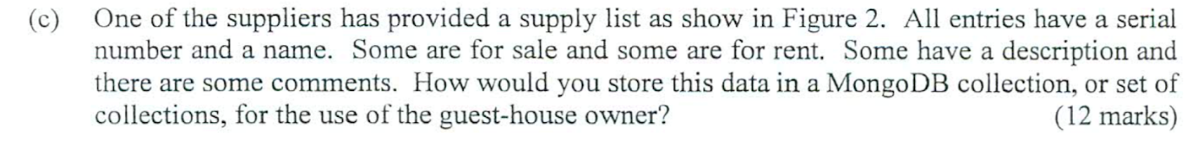

// NOTE controversial question: political answer ahead

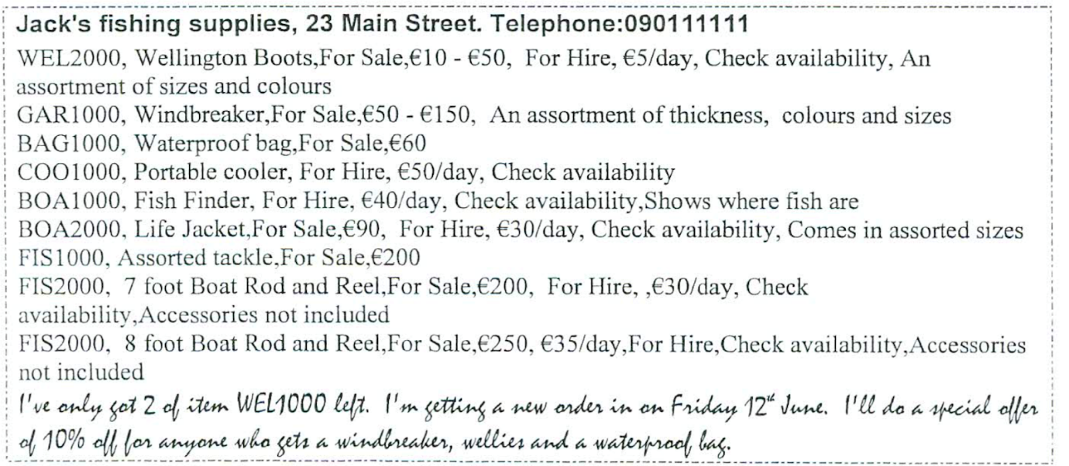

The above data encapsulates a single supplier with his/her list of items for hire/sale.

In mongoDB, these two entities can be stored in one collection i.e within the supplier collection, keep an array field (sub-collection) containing all items this supplier has.

Another way of storing the above data in mongoDB would be to have the items of each supplier as documents in a separate collection, keeping their _id as reference in the supplier collection within an array. This could be beneficial if embedding the item info with the supplier info within a subcollection array could make the supplier document exceed the 16Mb doc size allowed by mongoDB.

But this I would discourage if it is not the case in order to minimise the joins that will have to be done to query the fields of the items to hire/sale by the guest-house such as: checking if they are for hire/sale, their price range etc.

Q2. see others

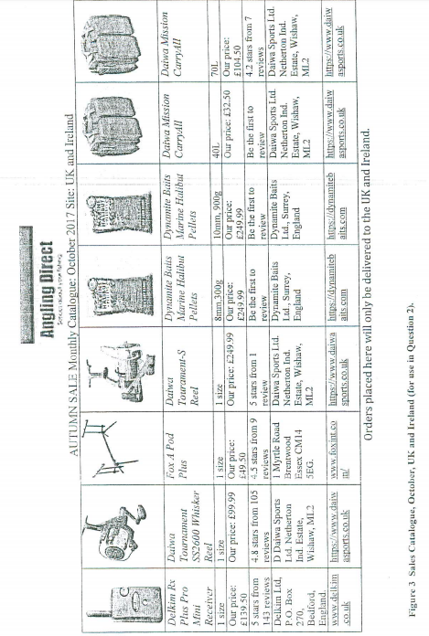

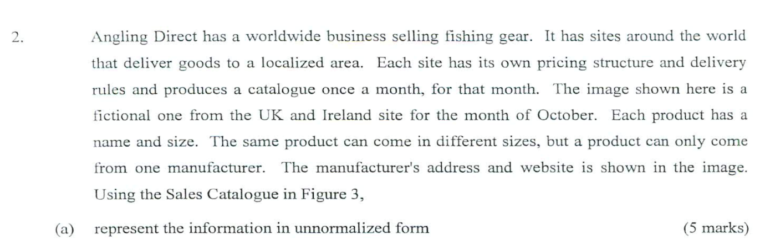

**UNF** :

* list attributes separating them with '+'
* remove duplicates(multiple values) of devivated fields (things that can be computed)
* surround repeating groups with { }

// star_count can be computed using an assumed review table

// review_count can also be computed using an assumed review table

// sizes is a duplicate

// the address also has values that needs to be broken down further

**Form** = region + month + product_name + ~~sizes~~ + price + ~~star_count~~ + ~~review_count~~ + ~~manufacturer_address~~+ manufacturer_website

**Form** =

{**region** + **month**} +

{**product_name** + price } +

{**review_id**, rating, review_text} +

{size_value} +

{manufacturer_website, address1+address2+ state}



**1st NF**: **1NF:** 

**2nd NF**:

Q3.

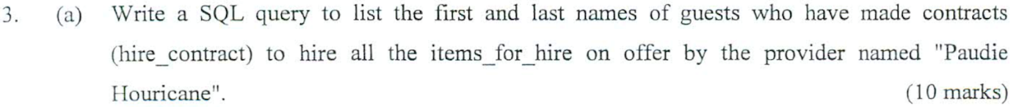

SELECT FIRST_NAME, LAST_NAME

FROM GUEST

JOIN HIRE_CONTRACT ON HIRE_CONTRACT.GUEST_NO = GUEST.GUEST_NO

**HAVING** COUNT(HIRE_CONTRACT.ITEM_KEY) = (

SELECT COUNT(ITEM_FOR_HIRE.ITEM_KEY)

FROM ITEM_FOR_HIRE

JOIN PROVIDER ON PROVIDER.PROVIDERID = ITEM_FOR_HIRE.PROVIDERID

WHERE PROVIDERNAME = ‘Paudie Houricane’);

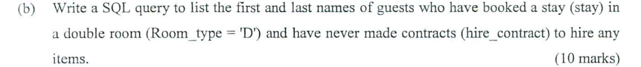

CREATE OR REPLACE VIEW NOHIRE AS

SELECT *

FROM GUEST WHERE GUEST.GUEST_NO

**NOT IN** (SELECT HIRE_CONTRACT.GUEST_NO FROM HIRE_CONTRACT);

SELECT NOHIRE.FIRST_NAME, NOHIRE.LAST_NAME

FROM NOHIRE

JOIN STAY ON STAY.GUEST_NO = HIRENO.GUEST_NO

JOIN ROOM ON ROOM.ROOM_NO = STAY.ROOM_NO

WHERE **ROOM.ROOM_TYPE = ‘D’;**

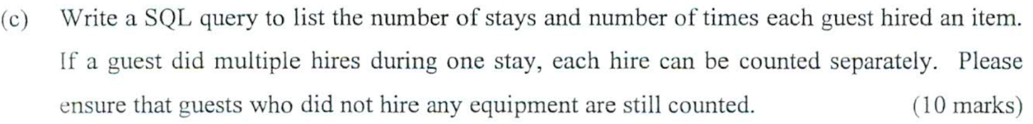



select last_name, first_name

from hire_contract

join items_for_hire using(item_key)

join guest using(guest_no)

join provider using(provider_id) // received when joining item_for_hire

where count(guest_no) = (

select count(item_key)

from items_for_hire

where lower(provider_name) like 'paudie houricane'

);

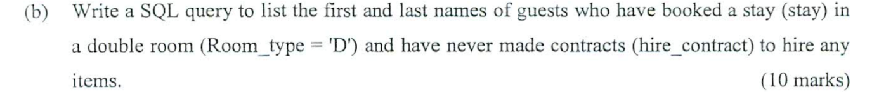

// alternatively joins and sets could be used

select last_name, first_name

from stay

join room using(room_no)

join guest using(guest_no)

where room_type='D' and  guest_no not in ( select guest_no from hire_contract);



SELECT COUNT(STAY.GUEST_NO) AS NOSTAYS, (SELECT COUNT(HIRE_CONTRACT.GUEST_NO FROM HIRE_CONTRACT

WHERE GUEST.GUEST_NO = HIRE_CONTRACT.GUEST_NO ) AS NOHIRES

FROM STAY

JOIN GUEST ON GUEST.GUEST_NO STAY.GUEST_NO;

// count the number of stay

select count(guest_no), num_of_stay = (

select count(guest_no) from stay

where stay.guest_no = guest_no

) from guest